

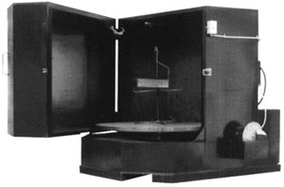

HARRIS TOOL COMPANY MODEL NO. WA-JUMBO 120 X 60 SUPER HEAVY DUTY PARTS WASHER WITH FOLLOWING SPECIFICATIONS:

- TOGGLE SWITCH OPERATED 18” STAINLESS DISC TYPE OIL SKIMMER
- 36 KW ELECTRIC HEATER
- REMOVEABLE TANK DEBRIS SCREEN (520 SQ. IN.)
- 25 HP CAST IRON VERTICAL SEALESS PUMP W/SCREEN(550 GPM @ 55 PSIG)
- 60 MIN.SPRING WOUND WASH TIMER
- 175 DEGREES F PROCESS THERMOSTAT CONTROLLER
- CRANE LOAD SLOT
- FORK LIFT CHANNELS FOR PORTABILITY
- 60 REPLACEABLE/CLEANABLE SPRAY JET NOZZLES
- 1300 GALLON CLEANING SOLUTION TANK
- LOW WATER SHUT-OFF SWITCH
- 5,000 LB. LOAD CAPACITY
- 60” INSIDE HEIGHT
- 1/2 HP GEARMOTOR/GEAR DRIVEN 120” DIA. HD TURNTABLE/TRUCK HUB ASSY. & JOG SWITCH
- 480/60/3 ELECTRICAL REQUIREMENTS
- INTERMEDIATE SPRAY BAR W/ NOZZLES & SHUTOFF VALVE
- HEAVY DUTY HINGED SEALESS DOOR W/ HANDLE, LATCH, AND SAFETY SWITCH
- 7 GAUGE TANK/12 GAUGE DOOR & CABINET STEEL MATERIAL
- 100” OVERALL HEIGHT
- 144”W X 144”D FLOOR SPACE REQUIRED W/ DOOR CLOSED
- PRECAUTION BLUE PAINT
- 7500 LBS. SHIPPING WT.

